1. Soil C pool data were from Table 1 (page 1010).

The paper does not report carbon density directly. We calculated carbon density from Table 1, which reported percent organic carbon and bulk density, but not carbon pool.

Soil c pool = Bulk density \* C%

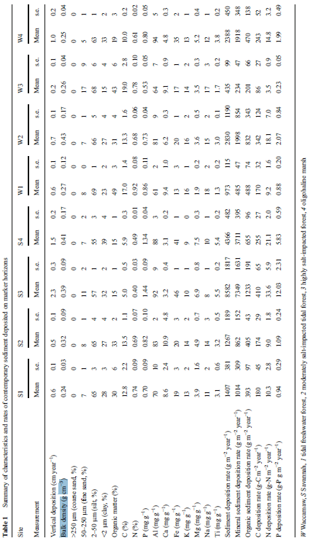

2. Soil C rate data were from Table 3. (page 1014)

